Akula Gopayya College of Engg & Tech

Usb 3.0

By
NAME : .B.JAYKISHAN & SNEHA THAKUR

1.Abstract

Universal Serial Bus (USB) is a serial bus standard to connect devices to a host computer. The USB 3.0 is the upcoming version of the USB. The USB 3.0 is also called super speed USB. Because the USB 3.0 support a raw throughput of 500MByte/s. As its previous versions it also support the plug and play capability, hot swapping etc. USB was designed to allow many peripherals to be connected using a single standardized interface socket. . Other convenient fea tures include providing power to low-consumption devices, eliminating the need for an external power supply; and allowing many devices to be used without requiring manufacturer-specific device drivers to be installed.

There are many new features include d in the new Universal Serial Bus Specification. The most im- portant one is the supers speed data transfer itself. Then the USB 3.0 can support more devices than the cur- rently using specification which is USB 2.0. The bus power spec has been increased so that a unit load is 150mA (+50% over minimum using USB 2.0). An unconfigured device can still draw only 1 unit load, but a configured device can draw up to 6 unit loads (900mA, an 80% increase over USB 2.0 at a registered maxim- um of 500mA). Minimum device operating voltage is dropped from 4.4V to 4V. When operating in Super- Speed mode, full -duplex signaling occurs over 2 differential pairs separate from the non-SuperSpeed differ- ential pair. This result in USB 3.0 cables containing 2 wires for power and ground, 2 wires for non-Super- Speed data, and 4 wires for SuperSpeed data, and a shield (not required in previous specifications).

HISTORY
Pre-Releases:

USB 0.7: Released in November 1994.

USB 0.8: Released in December 1994 .

USB 0.9: Released in April 1995.

USB 0.99: Released in August 1995.

USB 1.0: Released in November 1995.

USB 1.0
USB 1.0: Released in January 1996.
Specified data rates of 1.5 Mbit/s (Low-Speed) and 12 Mbit/s (Full-Speed). Does not allow for ex-tension cables or pass-through monitors(due to timing ,power limitations) . Few such devices actually made it to market.

USB 1.1: Released in September 1998.
Fixed problems identified in 1.0, mostly relating to hubs. Earliest revision to be widely adopted.

USB 2.0
USB 2.0: Released in April 2000.
Added higher maximum speed of 480 Mbit/s (now called Hi-Speed).

USB 3.0
On September 18, 2007, Pat Gelsinger demonstrated USB 3.0 at the Intel Developer Forum. The USB 3.0 Promoter Group announced on November 17, 2008, that version 1.0 of the specification has been completed and is transitioned to the USB Implementers Forum (USB -IF), the managing body of USB specifications. This move effectively opens the spec to hardware de velopers for implementation in future products.

FEATURES
A new major feature is the "SuperSpeed" bus, which provides a fourth transfer mode at 4.8 Gbit/s. The raw throughput is 4 Gbit/s, and the specification considers it reasonable to achieve 3.2 Gb it/s (0.4 GByte/s or 400 MByte/s) or more after protocol overhead .
To accommodate the additional pins for SuperSpeed mode, the physical form factors for USB 3.0 plugs and receptacles have been modified from those used in previous versions. Standard -A cables have extended heads where the SuperSpeed connectors extend beyond and slightly above the legacy connectors. Similarly, the Standard -A receptacle is deeper to accept these new connectors. On the other end, the SuperSpeed Standard -B connectors are placed on top of the existing form factor . A legacy
standard A-to-B cable will work as designed and will never contact any of the SuperSpeed connectors, ensuring backward compatibility. SuperSpeed standard A plugs will fit legacy A receptacles but SuperSpeed standard B plugs will not fit into legacy standard B receptacles (so a new cable can be used to connect a new device to an old host but not to connect a new host to an old device; for that, a legacy standard A-to-B cable will be required).
When operating in SuperSpeed mode, full-duplex signaling occurs over 2 differential pairs separate from the non -SuperSpeed differential pair.This results in USB 3.0 cables containing 2 wires for power and ground, 2 wires for non-SuperSpeed data, and 4 wires for SuperSpeed data, and a shield required

SuperSpeed establishes a communications pipe between t he host and each device, in a host -directed protocol. In contrast, USB 2.0 broadcasts packet traffic to all devices. USB 3.0 extends the bulk transfer type in SuperSpeed with Streams. This extension allows a host and device to create and transfer multiple streams of data through a single bulk pipe.
New power management features include support of idle, sleep and suspend states, as well as Link-, Device-, and Function -level power management.
The bus power spec has been increased so that a unit load is 150 mA(+50% over minimum using USB 2.0). An unconfigured device can still draw only 1 unit load, but a configured device can draw up to 6 unit loads(900 mA, an 80% increase over USB 2.0 at a registered maximum of 500 mA). Minimum device operating voltage is dr opped from 4.4 V to 4 V.
USB 3.0 does not define cable assembly lengths, except that it can be of any length as long as it meets all the requirements defined in thespecification.However, electronicdesign.com estimates cables will be limited to 3 m at SuperSpeed.
Technology is similar to a single channel (1x) of PCI Express 2.0 (5-Gbit/s). It uses 8B/10B encoding, linear feedback shift register (LFSR ) scrambling for data and spread spectrum. It forces receivers to use low frequency periodic signaling (LFPS), dynamic equalization, and training sequences to ensure fast signal locking.

CONNECTOR PROPERTIES

Availability

Consumer products are expected to become available in 2010.Commercial controllers are expected to enter into volume production no later than the first quarter of 2010.On September 24, 2009 Freecom announced a USB 3.0 external hard drive.
On October 27, 2009 Gigabyte Technology announced 7 new P55 chipsets motherboards that included onboard USB 3.0, SATA Rev. 3 (6Gb/s) and triple power to all USB ports.On January 6th, 2010 ASUS was the first manufacturer to release a USB 3.0 -certified motherboard, the P6X58D Premium.To ensure compatibility between motherboards and peripherals, all USB-certified devices must be approved by the USB Implementers Forum.
Drivers are under development for Windows 7, but support was not included with the initial release of the operating system. [57] The Linux kernel has supported USB 3.0 since version 2.6.31, whi ch was released in September 2009.
At least one complete end -to-end test system for USB3 designers is now on the market.
Intel will not support USB 3.0 until 2011
which will slow down mainstream adoption. These delays may be due to problems in the CMOS manufacturing process, a focus to advance the Nehalem platform or a tactic by Intel to boost its upcoming Light Peak interface. Current AMD roadmaps indicate that the new southbridges released in the beginning of 2010 will not support USB 3.0. Market researcher In-Stat predicts a relevant market share of USB 3.0 not until 2011 .
January 4, 2010 , Seagate announced a small portable HDD with PC.Card targeted for laptops (or desktop with PC Card slot addition) at the CES in Las Vegas.
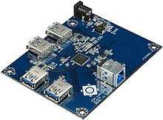

USB 3.0 Hub demo board using the VIA VL810 chip
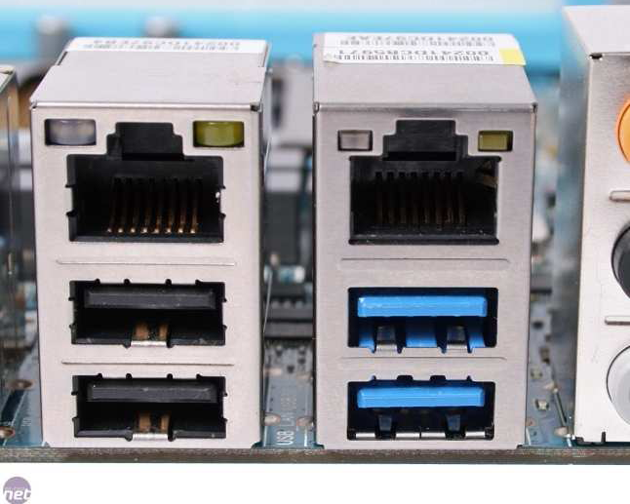
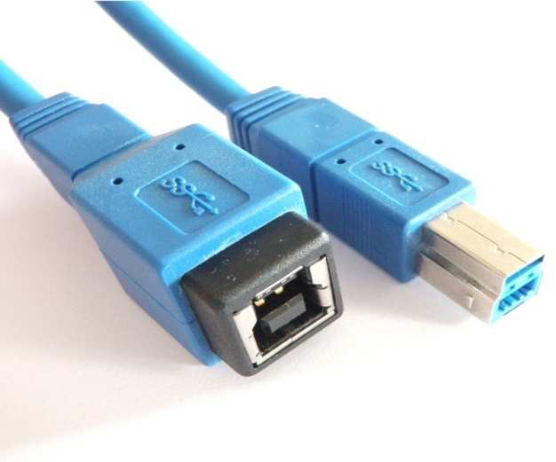

Usability

It is deliberately difficult to attach a USB connector incorrectly. Most connectors cannot be plugged in upside down, and it is clear from the appearance and kinesthetic sensation of making a connection when the plug and socket are correctly mated. However, it is not obvious at a glance to the inexperienced user (or to a user without sight of the installation) which way around the connector goes, thus it is often necessary to try both ways. More often than not, however, the side of the connector with the trident logo should be on "top" or "toward" the user.Most manufacturers do not, however, make the trident easily visible or detectable by touch.
Only moderate insertion / removal force is needed (by specification). USB cables and small USB devices are held in place by the gripping force from the receptacle (without need of the screws, clips, or thumbturns other connectors have required).
The force needed to make or break a connection is modest, allowing connections to be made in awkward circumstances (ie, behind a floor mounted chassis, or from below) or by those with motor disabilities. This has the disadvantage of easily and unintentionally breaking connections that one has intended to be permanent in case of cable accident (e.g., tripping, or inadvertent tugging).
The standard connectors were deliberately intended to enforce the directed topology of a USB network: type A connectors on host devices that supply power and type B connectors on target devices that receive power. This prevents users from accidentally connecting two USB power supplies to each other, which could lead to dangerously high currents, circuit failures, or even fire.

Durability

The standard connectors were designed to be robust. Many previous connector designs were fragile, specifying embedded component pins or other delicate parts which proved liable to bending or breaks, even with the application of only very modest force. The electrical contacts in a USB connector are protected by a n adjacent plastic tongue, and the entire connecting assembly is usually further protected by an enclosing metal sheath. As a result USB connectors can safely be handled, inserted, and removed, even by a young child .
The connector construction always ensures that the external sheath on the plug makes contact with its counterpart in the receptacle before any of the four connectors within mak e electrical contact. The external metallic sheath is typically connected to system ground, thus dissipating any potentially damaging static charges (rather than via delicate electronic components). This enclosure design also means that there is a (moderate) degree of protection from electromagnetic interference afforded to the
USB signal while it travels through the mated connector pair (this is the only location when the otherwise twisted data pair must travel a distance in parallel). In addition, because of the required sizes of the power and common connections, they are made after the system ground but before the data connections.
The newer Micro-USB receptacles are designed to allow up to 10,000 cycles of insertion and removal between the receptacle and plug, compared to 1500 for the standard USB and 5000 for the Mini -USB receptacle. This is accomplished by adding a locking device and by moving the leaf-spring connector from the jack to the plug, so that the most-stressed part is on the cable side of the connection.

Compatability

The USB standard specifies relatively loose tolerances for compliant US connectors, intending to minimize incompatibilities in connectors produced by different vendors (a goal that has been very successfully achieved). Unlike most other connector standards, the USB specification also defines limits to the size of a connecting device in the area around its plug. This was done to prevent a device from blocking adjacent ports due to the size of the cable strain relief mechanism (usually molding integral with the cable outer insulation) at the con nector. Compliant devices must either fit within the size restrictions or support a compliant extension cable which does.
Two-way communication is also possible. In USB 3.0, full –duplexcmmunications are done when using SuperSpeed (USB 3.0) transfer. In previous USB versions (ie, 1.x or 2.0), all communication is half-duplex and directionally controlled by the host.
USB 3.0 receptacles are electrically compatible with USB 2.0 device plugs if they can physically match. Most combinations will work, but there are a few physical incompatibilities. However, only USB 3.0 Standard-A receptacles can accept USB 3.0 Standard -A device plugs.
In general, cables have only plugs (very few have a receptacle on one end), and hosts and devices have only receptacles. Hosts almost universally have type -A receptacles, and devices one or another type -B variety. Type-A plugs mate only with type -A receptacles, and type -B with type-B; they are deliberately physically incompatible.

CONNECTION TYPES

Pin outs of Standard ,Mini, and Micro USB connectors
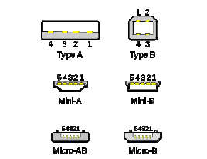

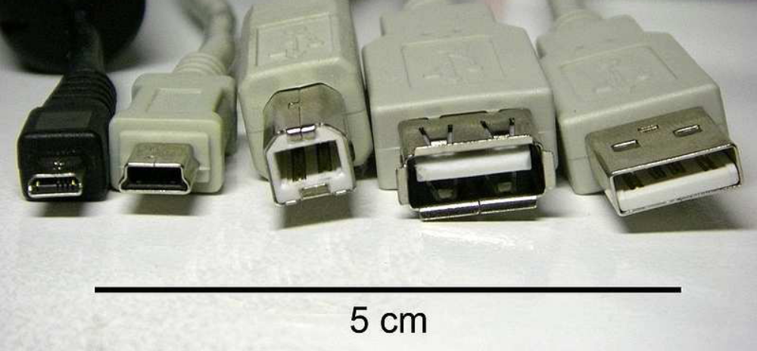
Different types of USB connectors from left to right:
Male micro USB
Male mini USB B-type
Male B-type
Female A-type
Male A-type

There are several types of USB connectors, including some that have been added while the specification progressed. The original USB specification detailed Standard-A and Standard -B plugs and receptacles. The first engineering change notice to the USB 2.0 specification added Mini -B plugs and receptacles. The data connectors in the A - Plug are actually recessed in the plug a s compared to the outside power connectors. This permits the power to connect first which prevents data errors by allowing the device to power up first and then transfer the data. Some devices will operate in different modes depending on whether the data connection is made. This difference in connection can be exploited by inserting the connector only partially. For example, some battery -powered MP3 players switch into file transfer mode (and cannot play MP3 files) while a USB plug is fully inserted, but can be operated in MP3 playback mode using USB power by inserting the plug only part way so that the power slots ake contact while the data slots do not. This enables those devices to be operated in P3 playback mode while getting power from the cable.

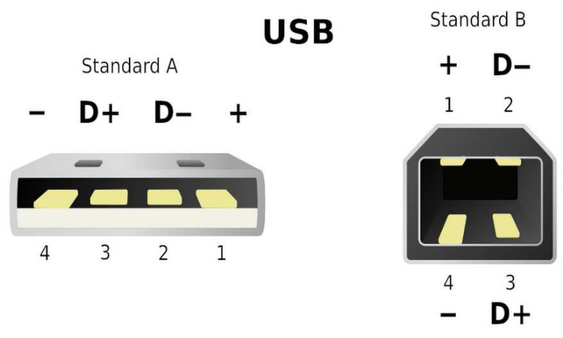
Pin configuration of the USB connectors Standard A/B, viewed from face of plug.

Comparisons With Other Device Connection Technologies
FireWire
USB was originally seen as a complement to FireWire (IEEE 1394), which was designed as a high-bandwidth serial bus which could efficiently interconnect peripherals such as hard disks, audio interfaces, and video equipment. USB originally operated at a far lower data rate and used much simpler hardware, and was suitable for small peripherals such as keyboards and mice.

The most significant technical differences between FireWire and USB include the following:
USB networks use a tiered-star topology, while FireWire networks use a tree topology.
USB 1.0, 1.1 and 2.0 use a "speak-when-spoken-to" protocol. Peripherals cannot Communicate with the host unless the h ost specifically requests communication. USB 3.0 is planned to allow for device -initiated communications towards the host (see USB 3.0 below). A FireWire device can communicate with any other node at any time, subject to network conditions.
A USB network relies on a single host at the top of the tree to control the network. In a FireWire network, any capable node can control the network.
USB runs with a 5 V power line, while Firewire (theoretically) can supply up to 30 V.
Standard USB hub ports can provide from the typical 500mA[2.5 Watts] of current, only 100mA from non -hub ports.
USB 3.0 & USB On-The -Go 1800mA[9.0W] (for dedicated battery charging, 1500mA[7.5W] Full bandwidth or 900mA[4.5W] High Bandwidth), while FireWire can in theory supply up to 60 watts of power, although 10 to 20 watts is more typical.

These and other differences reflect th e differing design goals of the two buses: USB was designed for simplicity and low cost, while FireWire was designed for high performance, particularly in time -sensitive applications such as audio and video. Although similar in theoretical maximum transfer rate, FireWire 400 has erformance advantage over USB 2.0 Hi -Bandwidth in real -use, especially in high-bandwidth use such as external hard -drives.
The newer FireWire 800 standard being twice as fast as FireWire 400 outperforms USB 2.0 Hi-Bandwidth both theoretically and practically.The chipset and drivers used to implement USB and Firewire have a crucial impact on how much of the bandwidth prescribed by the specification is achieved in the real world, along with compatibility with peripherals.

Power Over Ethernet
The 802.3af Power over Ethernet has superior power negotiation and optimization apabilities to powered USB. Power over Ethernet also supplies more power becau se it operates at 48V, 720mA while USB operates at 5V, 500mA. Ethernet also operates many more meters, with significant DC power loss, and will remain accordingly the preferred option for VoIP, security camera and other applications where networks extend through a building. However,USB is preferred when cost is critical.

Digital musical instruments
Digital musical instruments are another example of where USB is competitive for low-cost devices. However power over ethernet and the MIDI plug standard are preferred in high -end devices that must work with long cables. USB can cause ground loop problems in audio equipment because it connects the ground signals on both transceivers. By contrast, the MIDI plug standard and ethernet have built-in isolation to 500V or more.

eSATA
The eSATA connector is a more robust SATA connector, intended for connection to external hard drives and SSDs. It has a far higher tran sfer rate (3Gbps, bi-irectional) than USB 2.0. A device connected by eSATA appears as an ordinary SATA device, giving both full performance and full compatibility associated with internal drives.
eSATA does not supply power to external devices. This may s eem as a disadvantage compared to USB, but in fact USB's 2.5W is usually insufficient to power external hard drives. eSATAp (power over eSATA) is a new (2009) standard that supplies sufficient power to attached devices using a new, backwards-compatible, co nnector.
eSATA, like USB, supports hot plugging, although this might be limited by OS drivers.

Cables
The maximum length of a standard USB cable (for USB 2.0 or earlier) is 5.0 metres (16.4 ft). The primary reason for this limit is the maximum allowed round-trip delay of about 1,500 ns. If USB host commands are unanswered by the USB device within the allowed time, the host considers the command lost.
When adding USB device response time, delays from the maximum number of hubs added to the delays from connecting cables, the maximum acceptable delay per cable amounts to be 26 ns.
The USB 2.0 specification requires cable delay to be less than 5.2 ns per meter (192,000 km/s, which is close to the maximum achievable bandwidth for standard copper cable). This allows for a 5 meter cable. The USB 3.0 standard does not directly specify a maximum cable length, requir ing only that all cables meet an electrical specification. For copper wire cabling, some calculations have suggested a maximum length of perhaps 3m.
No fiber optic cable designs are known to be under development, but they would be likely to have a much longer maximum allowable length, and more complex construction.
The data cables for USB 1.x and USB 2.x use a twisted pair to reduce noise and crosstalk. They are arranged much as in the diagram below. USB 3.0
cables are more complex and employ shielding for some of the added data lines (2 pairs); a shield is added around the pair sketched.

Pin | Name | Cable color | Description
1 | VCC | Red | +5V
2 | D- | White | Data-
3 | D+ | Green | Data+
4 | GND | Black | Ground

USB 1.x/2.0 cable wiring

Pin | Name | Color | Description
1 | VCC | Red | +5V
2 | D- | White | Data-
3 | D+ | Green | Data-
4 | ID | None | Permits distinction of Micro-A and Micro-B_plug  Type A:connected to ground  Type B:not connected.
5 | GND | Black | Signal ground

USB 1.x/2.0 Miniplug/Microplug.

Maximum cable length

USB 1.1 maximum cable length is 3 metres (9.8 ft) and USB 2.0 maximum cable length is 5 metres (16 ft). Maximum permitted hubs connected in series is 5. Although a single cable is limited to 5 metres, the USB 2.0 specification permits up to five USB hubs in a long chain of cables and hubs.
This allows for a maximum distance of 30 metres (98 ft) between host and device, using six cables 5 metres (16 ft) long and five hubs. In actual use, since some USB devices have built-in cables for connecting to the hub, the maximum achievable distance is 25 metres (82 ft) + the length of the device's cable. For longer lengths, USB extenders that use CAT5 cable can increase the distance between USB devices up to 50 metres (160 ft).
A method of extending USB beyond 5 metres (16 ft) is by using low resistance cable.The higher cost of USB 2.0 Cat 5 extenders has urged some manufacturers to use other methods to extend USB, such as using built-in USB hubs, and custom low-resistance USB cable. It is important to note that devices which use more bus power, such as USB hard drives and USB scanners will require the use of a powered USB hub at the end of the extension, so that a constant connection will be achieved. If power and data does not have sufficient power then problems can result, such as no connection at all, or intermittent connections during use.

USB 3.0 cable assembly may be of any length as long as all requirements defined in the specification are met. However, maximum bandwidth can be achieved across a maximum cable length of approximately 3 metres.

Power
The USB 1.x and 2.0 specifications provide a 5 V supply on a single wirefrom which connected USB devices may draw power. The specification provides for no more than 5.25 V and no less than 4.75 V (5 V±5%) between the positive and negative bus power lines. For USB 2.0 the voltage supplied by low-powered hub port s is 4.4 V to 5.25 V.
A unit load is defined as 100 mA in USB 2.0, and was raised to 150 mA in USB 3.0. A maximum of 5 unit loads (500 mA) can be drawn from a port in USB 2.0, which was raised to 6 (900 mA) in USB 3.0. There are two types of devices: low-power and high-power. Low-power devices draw at most 1 unit load, with minimum operating voltage of 4.4 V in USB 2.0, and 4 V in USB 3.0. High-power devices draw the maximum number of unit loads supported by the standard. All devices default as low -power but the device's software may request high -power as long as the power is available on the providing bus.
A bus-powered hub is initialized at 1 unit load and transitions to maximum unit loads after hub configuration is obtained. Any device connected to the hub will draw 1 unit load regardless of the current draw of devices connected to other ports of the hub (i.e one device connected on a four -port hub will only draw 1 unit load despite the fact that all unit loads are being supplied to the hub).
A self-powered hub will supply maximum supported unit loads to any device connected to it. A battery -powered hub may supply maximum unit loads to ports. In addition, the VBUS will supply 1 unit load upstream for communication if parts of the Hub are powered down.

In Battery Charging Specification, new powering modes are added to the USB specification. A host or hub Charging Downstream Port can supply a maximum of 1.5 A when communicating at low-bandwidth or full-bandwidth, a maximum of 900 mA when communicating at hig h-bandwidth, and as much current as the connector will safely handle when no communication is ta king place; USB 2.0 standard -A connectors are rated at 1500 mA by default.
A Dedicated Charging Port can supply a maximum of 1.8 A of current at 5.25 V. A portable device can draw up to 1.8 A from a Dedicated Charging Port. The Dedicated Charging Port shorts the D+ and D- pins with a resistance of at most 200 . The short disables data transfer, but allows devices to detect the Dedicated Charging Port and allows very simple, high current chargers to be manufactured.

Powered USB
Powered USB uses standard USB signaling with the addition of extra power lines. It uses four additional pins to supply up to 6 A at either 5 V, 12 V, or 24 V (depending on keying) to peripheral devices. The wires and contacts on the USB portion have been upgraded to support higher current on the 5 V line, as well.
This is commonly used in retail systems and provides enough power to operate stationary barcode scanners, printers, pin pads, signature capture devices, etc. This modification of the USB interface is proprietary and was developed by IBM, NCR, and FCI/Berg.
It is essentially two connectors stacked such that the bottom connector accepts a standard USB plug and the top connector takes a power connector.

Sleep-and-Charge
Sleep-and-charge USB ports can be used to charge electronic devices even when the computer is switched off.

USB 2.0 Data Rates
The theoretical maximum data rate in USB 2.0 is 480 Mbit/s (60 MB/s) per controller and is shared amongst all attached devices. S ome chipset manufacturers overcome this bottleneck by providing multiple USB 2.0 controllers within the Southbridge. Big performance gains can be achieved when attaching multiple high bandwidth USB devices such as disk enclosures in different controllers. The following table displays Southbridge ICs that have multiple EHCI controllers.

Vendor | South bridge | USB 2.0  Ports | EHCI Controllers | Maximum Data Rate
AMD | SB7x0/SP5100 | 12 | 2 | 120 MB/s
AMD | SB8x0 | 14 | 3 | 120 MB/s
BROADCOM | HT1100 | 12 | 3 | 120 MB/s
Intel | ICH8 | 10 | 2 | 120 MB/s
Intel | ICH9 | 12 | 2 | 120 MB/s
Intel | ICH10 | 12 | 2 | 120 MB/s
Intel | PCH | 8/12/14 | 2 | 120 MB/s
Intel | ION/ION-LE | 12 | 2 | 120 MB/s

Every other AMD, Broadcom, Intel southbridge supporting USB 2.0 has only one EHCI controller. All SiS southbridge supporting USB 2.0 have only one EHCI controller. All ULi, VIA southbridge, single chip northbridge/southbridge supporting USB 2.0 have only one EHCI controller.
Also all PCI USB 2.0 ICs used for add -in cards have only one EHCI controller. Despite that some card manufacturers offer improved cards which have 2 PCI USB 2.0 ICs attached to one PCI to PCI bridge.
In PCIe, the usual design with multiple USB ports per EHCI controller has changed with the introduction of the MosChip MCS9990 IC. MCS9990 has one EHCI controller per port so all its USB ports can operate simultaneously without any performance limitations. Dual IC cards have been introduced as well and come with 2 PCI USB 2.0 ICs attached to one PCI to PCIe bridge.

Signaling
USB supports following signaling rates:
A low-bandwidth rate of 1.5 Mbit/s (~183 KB/s) is defined by USB 1.0. It is very similar to "full-bandwidth" operation except each bit takes 8 times as long to transmit. It is intended primarily to save cost in low -bandwidth human interface devices (HID) such as keyboards, mice, and joysticks.
The full-bandwidth rate of 12 Mbit/s (~1.43 MB/s) is the basic USB data rate defined by USB 1.1. All USB hubs support full -bandwidth.
A hi-bandwidth (USB 2.0) rate of 480 Mbit/s (~57 MB/s) was introduced in 2001. All hi-bandwidth devices are capable of falling back to full-bandwidth operation if necessary; they are backward compat ible.Connectors are identical.
A SuperSpeed (USB 3.0) rate of 4.8 Gbit/s (~572 MB/s). The written USB 3.0 specification was released by Inte l and partners in August 2008. The first USB 3 controller chips were sampled by NEC May 2009 and products using the 3.0 specification are expected to arrive beginning in Q3 2009 and 2010.USB 3.0 connectors are generally backwards compatible, but include new wiring and full duplex operation.
Prior to USB 3.0, these collectively use half-duplex differential signaling to reduce the effects of electromagnetic noise on longer lines. Transmitted signal levels are 0.0 0.3 volts for low and 2.8 3.6 volts for high in full-bandwidth and low-bandwidth modes, and í10 10 mV for low and 360 -440 mV for high in hi -bandwidth mode.

A USB connection is always between a host or hub at the "A" connec tor end, and a device or hub's "upstream" port at the other end. Originally, this was a "B' connector, preventing erroneous loop connections, but additional upstream connectors were specified, and some cable vendors designed and sold cables which permitted erroneous connections (and potential damage to the circuitry).
USB interconnections are not as fool -proof or as simple as originally intended.
The host includes 15 k pull-down resistors on each data line. When no device is connected, this pulls both data lines low into the so-called "single -ended zero" state (SE0 in the USB documentation), and indicates a reset or disconnected connection.
Though high bandwidth devices are commonly referred to as "USB 2.0" and advertised as "up to 480 Mbit/s", not all USB 2.0 devices are high bandwidth.
The USB-IF certifies devices and provides licenses to use special marketing logos for either "basic bandwidth" (low and full) or high bandwidth after passing a compliance test and paying a licensing fee. All devices are tested according to the latest specification, so recently-compliant low bandwidth devices are also 2.0 devices.
The actual throughput currently (2006) of USB 2.0 high bandwidth attained with real -world devices is about two thirds of the maximum theoretical bulk data transfer rate of 53.248 MiB/s. Typical high bandwidth USB devices operate at lower data rates, often about 3 MiB/s overall, sometimes up to 10 20 MiB/s.

ARCHITECTURAL COMPONENTS

HUB
The hub provide electrical interface between the USB devices and the host. Hubs are directly responsible for supporting many of the attributes that make USB user friendly and hide its complexity from the user. Listed below the major aspects of USB functionality that hub support:

Connectivity behavior
Power management
Device connect/disconnect detection
Bus fault detection
Superspeed and USB2.0 (high -speed, full-speed, an low-speed) support A.

USB 3.0 hub incorporates a USB 2.0 hub and a SuperSpeed hub consisting of two principal components: the SuperSpeed Hub Repeater/Forwarder and the SuperSpeed Hub controller. The hub repeater/forwarder is responsible for connectivity and setup and tear -down. It also support fault detection and recovery. The Hub controller provides the mechanism for host-hub communication. Hub -specific status and control commands permit the host to configure hub and to monitor and control its individual downstream port.

HOST
There are two hosts are incorporated in a USB 3.0 host. One is SuperSpeed host and the second one is Non -SuperSpeed host. This incorporation ensures the backward compatibility of the USB 3.0 hub. Here the SuperSpeed hub will be supporting the 500MB/sec data transfer rate with full duplex mode. Then the Non-SuperSpeed host will be supporting the old data rates such as High -Speed, Full-Speed, Low-Speed. The host here interacts with the devices by the help of a host controller.

When the host is powered off, the hub does not provide power to is downstream unless the hub support the charging application. When the host is powered on with SuperSpeed support enabled on its downstream port by default the following is the typical sequence of events.

Hub detects VBUS SuperSpeed support and powers its downstream ports with SuperSpeed enabled.

Hub connects both as s SuperSpeed and as a High -Speed device.
Device detects VBUS and SuperSpeed support and connects as a
SuperSpeed device.
Host system begins hub enumeration at high-speed and SuperSpeed.
Host system begins device enumeration at SuperSpeed.

SuperSpeed host is a source or sink of information. It implements the required host-end, SuperSpeed. Communications layer to accomplish information exchanges over the bus.
It owns the SuperSpeed data activity schedule and management of the SuperSpeed bus and all devices connected to it. The host includes an implementation number of the root downstream ports for SuperSpeed and USB 2.0. Through these ports the host:

Detect the attachment and removal of USB device
Manages control flow between the host and the USB device
Manages data flow between the host and the USB device
Collect the status activity statistics
Provide power to the attached USB device

DEVICE
SuperSpeed devices are sources or sink of information exchanges. They implement the required device -end, SuperSpeed communication layers to accomplish information exchanges between a driver on the host and a logical function on the device. All SuperSpeed devices sha re their base architecture with USB 2.0.
They are required to carry information for self -identification and generic configuration. They are also required to demonstrate behavior consistent with the defined SuperSpeed Device States.
All devices are assigned a USB address when enumerated by the host. Each device supports one or more pipes though which the host may communicate with the device.
All devices must be support a designed pipe at endpoint zero to which the devices Default Control Pipe is attached. All devises support a common access mechanism for accessing information through this control pipe.

The USB 3.0 supports an increased power supply for the devices operating at the SuperSpeed. USB 3.0 devices within a single physica l package(ie, a single peripheral) can consist of a number of functional topologies including single function , multiple functions on a single peripheral device (composite device), and permanently attached peripheral devices behind an integrated hub.

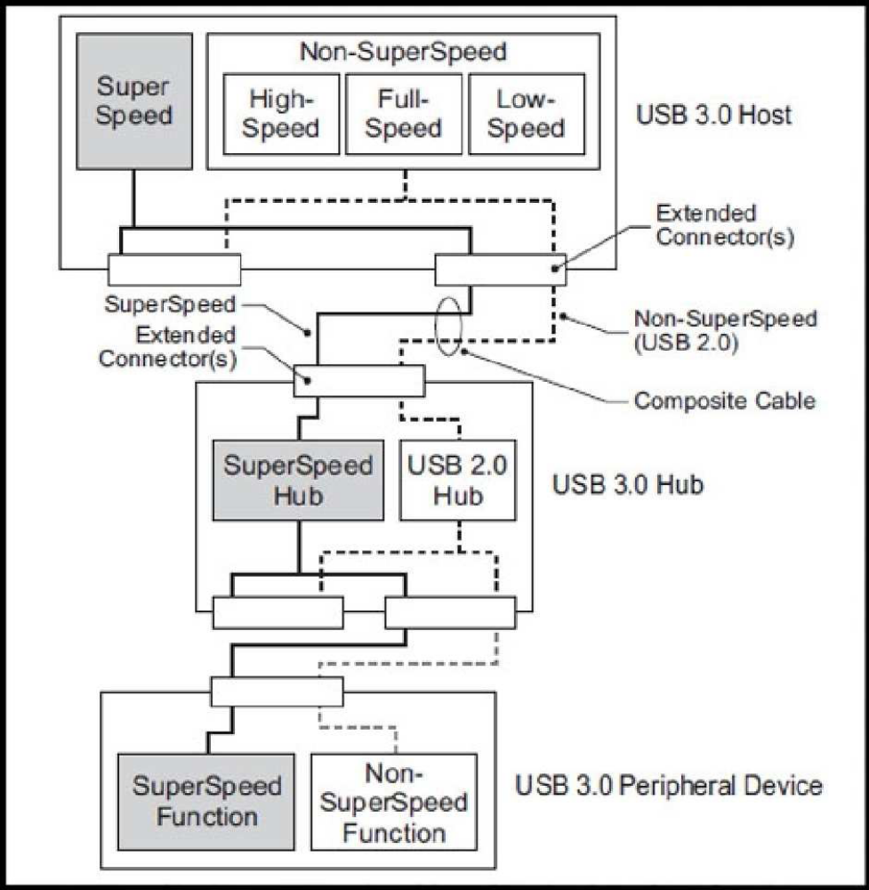

ARCHITECTURE OF USB 3.0
APPLICATIONS
The USB ports are used for a number of applications. The USB ports get the popularity because of its simplicity as well the easiness in use. The main application of USB 3.0 is listed below.

USB implements connections to stora ge devices using a set of standards called the USB mass storage device class (referred to as MSC or UMS).
This was initially intended for traditional magnetic and optical drives, but has been extended to support a wide variety of devices, particularly flash drives. This generality is because many systems can be controlled with the familiar idiom of file manipulation within directories (The process of making a novel device look like a familiar device i s also known as extension)

USB 3.0 can also support portable hard disk drives. The earlier versions of USBs were not supporting the 3.5 inch hard disk drives. Originally conceived and still used today for optical storage devices (CD -RW drives, DVD drives, etc.), a number of manufacturers offer external portable USB hard drives, or empty enclosures for drives, that offer performance comparable to internal drives.

These external drives usually contain a translating device that interfaces a drive of conventional technology (IDE, ATA, SATA, ATAPI, or even SCSI) to a USB port. Functionally, the drive appears to the user just like an internal drive.

These are used to provide power for low power consuming devises. These can be used for charging the mobile phones.

Though most newer computers are capable of booting off USB Mass torage devices, USB is not intended to be a primary bus for a computer's internal storage: buses such as ATA (IDE), Serial ATA (SATA), and SCSI fulfill that role. However, USB has one important advantage in that it is possible to install and remove devices without opening the computer case, making it useful for external drives.

Mice and keyboards are frequently fitted with USB connectors, but because most PC motherboards still retain PS/2 connectors for the keyboard and mouse as of 2007, they are often supplied with a small USB-to-PS/2 adaptor, allowing usage with either USB or PS/2 interface.

Joysticks, keypads, tablets and other human -interface devices are also progressively migrating from MIDI, PC game port, and PS/2 connectors to USB.

It can also support Ethernet adapter, modem, serial port adapter etc

It can support Ful l speed hub, hi-speed hub, and SuperSpeed hub.

It can support USB smart card reader, USB compliance testing devices, Wi-Fi adapter, Bluetooth adapter, ActiveSync device, Force feedback joystick _

CONCLUSION

The Universal serial bus 3.0 is supporting a speed of about 5 Gb/sec ie ten times faster than the 2.0 version. And it is also faster than the new Firewire product S3200. So hopefully by the help of this SuperSpeed data transfer rate the USB 3.0 will be replacing many of the connecters in the future. The prototype of the USB 3.0 was already implemented by ASUSE in their motherboard. The drivers for the USB 3.0 are made available to the opensource Linux. The Linux kernel will support USB 3.0 with version 2.6.31, which will be released around August. Bec ause of the backward compatibility of the USB 3.0 the devises which we are using now and the ports we are using now(which is USB 2.0) will be working proper with the new USB 3.0 devises and ports.
Consumer products are expected to become available in 2010. Commercial controllers are expected to enter into volume production no later than the first quarter of 2010.

