A PAPER PRESENTATION ON

INKLESS PRINTING IN MOBILES

AKULA GOPAYYA COLLEGE OF ENGINEERING &TECHNOLOGY
(TADEPALLIGUDEM)

DEPARTMENT OF COMPUTER SCIENCE AND ENGINEERING

SUBMITTED BY:

V.VIJAYA LAKSHMI N.VASUNDHARA T.DIVYA SREE
(3/4C.S.E) (3/4C.S.E) (3/4C.S.E)
vasundhara.nanobolu@gmai.com chati.sree@gmail.com

Abstract:

In an increasingly paperless world, you'd guess printing would become obsolete. But that's not the case. Because reading computer screens strains people's eyes and they prefer to hold a book or newspaper in their hands, printing technology remains indispensable.
The paper we are going to present gives you an idea about the problems in achieving portability and convenience while using the old fashioned printing technologies that uses the ink and how the ink less technologies mentioned in our paper will emerge sweeping these drawbacks.

Here, we use the latest mobile photo printer which takes the advantages of inkless technology. These portable mobile printers are sized 10 times less than the conventional printers that aren’t much bigger than a pack of cards.

This paper also describes the “Zink paper” in which the ink is embedded in 3 layers of heat reactive dye crystals sandwiched between a base and a protective over coat layer,
which will be converted into a richly colored dye on application of a heat chemical reaction

In future, inkless technologies may not completely throw the existing or traditional technologies but they may coexist with them. It is also expected that in long run it may have a multi billon impact on the industry

Introduction:
Technology seems to have come full circle since the invention of ink some 4,000 years ago. Although the printing press, an efficient way to apply ink to paper on a mass scale, was one of the most important technological advances in the history of humanity, taking ink out of the equation can simplify modern printers.
Generally, true ink consists of a dye or pigment, which can be organic or inorganic, in a liquid. A dye is a colored substance that dissolves in a liquid solvent, while a pigment consists of very fine, sometimes powdery, colored particles that don't dissolve, but rather are suspended in a liquid. The solvents and liquid that hold the dye or pigment can be water, or even oils or alcohols.
Ink on paper was the only way to display words and images, and it still beats computer displays when it comes to portability and price. Yet it does have some limitations: Once you've printed words on paper, those words cannot be changed without at least leaving some marks.

In this paper we are going to see the modern photo printing technologies that do not use the mechanism that requires ink. Zink has perfected a technology for printing without ink. Using embedded dye crystals in the paper, a printer merely needs to apply the right amount of heat to bring those crystals alive and produce a quality print. Because there's no need for ink, this special paper allows printers to be exceptionally small. Some stationary photo printers are advertised as "mobile" because they receive wireless signals to print. Zink had introduced a powerful inkless mobile photo printing technology.

Modern Inkless Printing Methods
Thermal fax machine:
This useful gadget merely needs to apply heat to special thermal paper to print text or images. Without the mechanisms that ink requires, the printer is simpler, more durable, cheaper to maintain and takes up less space than ink printers. A different type of thermal fax machine uses ribbon rather than ink and melts the ribbon to paper to print text.
Photocopiers:
Conventional photocopiers actually use a dry, powdery material called toner. The toner is negatively charged, and the copier uses static electricity to print copies. The copier uses light to measure the print on the original and assembles the powdery toner to fall to positively charged areas to replicate the text or image. It then fuses the toner to another piece of paper to make a copy.
Zink paper uses embedded dye crystals that react to heat to print an image.

Xerox: It is also developing an inkless printing method that is intentionally working to make inkless prints easily erasable Xerox is developing paper that doesn't require ink and is completely reusable. Xerox first coats paper in heliochromic chemicals. These chemicals darken when the paper is exposed to ultraviolet light (UV). With prototypes of this technology, the print automatically fades 16 to 24 hours after printing.

What is ZINK™?
ZINK™ stands for Zero Ink™ - an amazing new way to print in full color without the need for ink cartridges or ribbons. The ZINK Technology encompasses both the ZINK Paper™ and the intelligence embedded in every ZINK-enabled device. The technology enables a new category of color printing devices and paper that work as a system to print in a whole new way.
ZINK Technology is based on advances in chemistry, engineering, physics, image science, and manufacturing. ZINK was developed over several years and has generated an IP portfolio that includes over 100 patents and patents pending. And development of the next generation of ZINK continues in our labs daily.
How ZINK™ Works

At the heart of the ZINK Technology is the patented ZINK Paper, an advanced composite material with cyan, yellow, and magenta dye crystals embedded inside, and a protective polymer overcoat layer outside. The crystals are colorless before printing, so ZINK Paper looks like regular white photo paper. Heat from a ZINK-enabled device activates the crystals, forming all the colors of the rainbow. The printing process is now radically simple

How Zink is used in Mobile photo printer:
We usually save pictures in our phones or digital camera. While taking digital pictures we miss the old-fashion hard copy photos. This is because the printers available are bulky and inconvenient to use. Lucky for us, new mobile photo printers are making it easier and faster for us to free our trapped images from their digital prisons -- all without using a drop of ink.
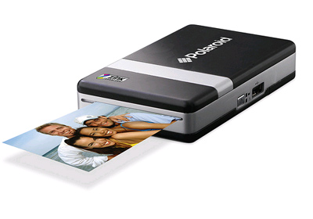
Without ink, photo printers can be dramatically smaller than their predecessors, making them more convenient and even portable. Some stationary photo printers are advertised as "mobile" because they receive wireless signals to print. However, with inkless printing technology, printers can be mobile in a more radical way -- you can carry it around in a pocket or a purse, just like a cell phone. And best of all, because it doesn't need any kind of traditional ink, the maintenance is as easy as refilling photo paper.
Specifications of Ink free portable photo printers:
In 2007, a Polaroid spin-off company called Zink unveiled its ink-free printing technology. Then the company teamed up with Polaroid to develop a pocket-sized printer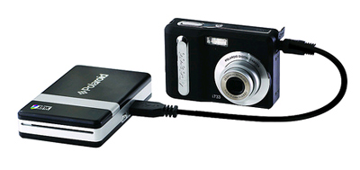
printing from a digital camera requires
connecting a USB wire.
The PoGo printer connects to a digital camera through a USB adapter wire, allowing the printer and the camera to directly connect without a computer. Connecting the printer to your cell phone, on the other hand, requires no wires. Instead the printer can use a Bluetooth connection to receive images from the phone. When it receives the data, the printer prints out a 2-inch by 3-inch color photo. The resulting picture has a peel-off back that exposes a sticky adhesive -- so this photo can be used as a label.
When the printer is functioning on its lithium-ion battery, it can print as many as 15 photos. When it's plugged in, the AC adaptor (the power cord that adjusts the right current and voltage needed) can keep the printer going for endless prints. With the rechargeable battery attached (but without paper), the printer weighs about 8 ounces. And, at 0.9 inches by 4.7 inches by 2.8 inches, it holds up to 10 sheets and is not much bigger than a pack of cards. Polaroid is banking on the device's convenient size and weight to attract consumers who'd like to carry it around with their cell phone or digital camera.
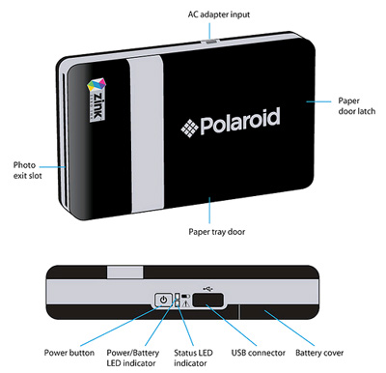
In future printers will even be built into cell phones. As there's no need for ink (just paper), compatible printers won't add too much weight or size when attached to a phone or any other device for that matter. Not only that, but because the special printing process can go beyond just photos, Zink's plans also include incorporating a printer with similar technology into devices such as laptops.

Ink-free Mobile Photo Printer Paper:

The Magic Behind Portable Photo Printers
So how do you print a quality photo by installing just paper and absolutely no ink? It's no magic trick -- the answer lies in the paper itself. Observe: before printing, the blank Zink paper is white and seemingly normal. However, like the saying goes, it's what's inside that matter. 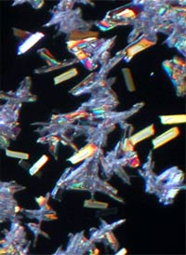
These microscopic crystals are the only "ink" that Zink paper needs.
Scientists at Zink invented a paper that contains all the "ink" necessary to make a photo. Each sheet of the Zink paper contains dye crystals: some that can turn cyan, some that can turn magenta, and some that can turn yellow. These crystals are imperceptible to the naked eye and, before printing, are colorless. To activate this untapped, imperceptible "ink" in the crystals, add heat to the equation. Heat causes a chemical reaction in these specially designed crystals, turning them from colorless crystals to richly colored dye.
To get a closer look at how the paper works, let's inspect the different layers:
- Base layer: This first layer provides the paper template on which to place layers of crystals. This layer can also have an adhesive back, as with the Polaroid PoGo instant mobile printer.
- Cyan imaging layer: an image-forming layer that releases a cyan-colored dye when activated at a lower temperature for a long time.
- Magenta imaging layer: the layer that releases magenta dye when activated at a medium temperature for a medium amount of time.
- Yellow imaging layer: This layer releases yellow dye when activated at a high temperature for a short amount of time.
- Overcoat layer: Last, but not least, is this protective layer of clear polymer that seals the paper, which allows it to resist damage from light, heat and water. This layer lends the photo a traditional glossy feel.
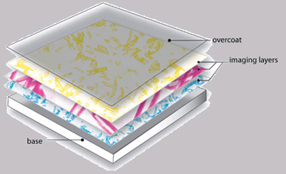
In Zink paper, the "ink" is embedded in three layers of heat-reactive dye crystals, sandwiched between a base and protective overcoat layer.
Also, interlayers in between the imaging layers listed above keep the imaging layers separate from each other.
As the paper goes through the thermal printhead, the color activated depends on the printhead's temperature and time of application. For example, if the printer needs to activate magenta alone, the heat applied will not be hot enough to activate yellow crystals and won't be applied long enough to activate cyan crystals.
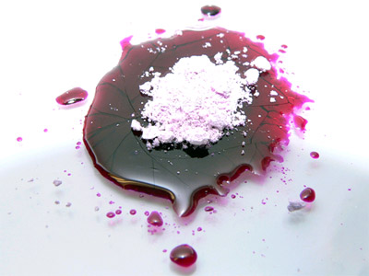
Here, a pile of unrefined dye crystals sits on a pool
of activated magenta dye.
The "lower" temperatures and "longer" amounts of time used on these printers are really neither low nor long -- temperatures are hot, ranging from 212 to 392 degrees Fahrenheit (100 to 200 degrees Celsius), and printing one line takes only 16 milliseconds.
Different mixtures of cyan, magenta and yellow can yield all the colors that you need to print a quality image. Each 2-inch by 3-inch sheet contains about 100 billion dye crystals and gets activated by 200 million heat pulses.
Although years of toil went into perfecting the science of this paper, Zink has managed to produce it cheaply enough to sell it for about $3 per 10-pack (about 33 cents per sheet) for the PoGo printer. And, although Polaroid's PoGo printer uses 2-inch by 3-inch paper, Zink can produce paper of any size. As Zink and its other partnering companies develop other compatible printers, more sizes will be available.
Advantages:
- The obvious advantage of the product is that it's small and light. It can satisfy instant gratification -- you don't have to wait to get home to a stationary printer to get finished prints of your images.
- Eco-conscious people will find that the paper is recyclable (unlike thermal paper) and non-toxic. Also, because there is no ink cartridge or ribbon to dispose of, the printer produces no waste.
Disadvantages:
- It was claimed that half of his test photos came out with skewed coloration and that some were "washed out"
- One expert reviewer David Stone tested the supposed water resistance the printer advertises and found that, although the photos sustain drops that are immediately wiped off, the image suffers if drops dry on it.

CONCLUSION:
Through this paper we can conclude that the latest ink less printing technology using a pocket size device can set the enslaved digital images trapped in phones and digital cameras free.
In addition to sharing similarities with other printing methods, namely dye diffusion thermal transfer or dye sublimation methods, the methods to print using Ink free paper removes the need of middle man(such as a ribbon that contains ink) i.e., the only materials it needs are the paper and printer.

References:

Bergstein, Brain.” Polaroid plans mobile printers—no ink needed “
http://www.msnbc.msn.com/id

Bhatt, jayprakash c.” thermal image of system”
http://www.patentsonline.com/

http://computer.howstuffworks.com/print-without-ink.htm

http://communication.howstuffworks.com/thermal-fax-machine.htm

